MULTIBODY MODEL

We designed our mechanism using Adams View.

As shown in the figure above, the mechanism is made up of:

* two links
* a mass
* a cam
* a follower
* a roller
* a plate

The green link is the crank whereas the yellow one is the coupler link. The lengths of the links are taken from the Matlab code and the material selected is steel. The mass is located in correspondence of the origin of the crank and it accounts for the inertia of the tilting pad. The plate is used to connect the coupler and the follower, and from a computational point of view is part of the follower.

The cam was designed using the Cam Machinery tool of Adams.

The first step is creating the follower motion, therefore we imported the data of the translation of the follower from Matlab. Knowing the displacement, Adams calculates acceleration and jerk.

The second step is creating the cam profile. We selected a disk shape, a minimum radius of 100 mm and a circular end radius of the follower of 25 mm. We decided to neglect the spring of the follower because we want a kinematic simulation.

At last, the cam is created.

The joints between the different parts of the mechanism are:

|  |  |  |
| --- | --- | --- |
| JOINT | BODIES | DOC |
| Revolute joint | Crank/Ground | 5 |
| Fixed joint | Mass/Crank | 6 |
| Hooke joint | Crank/Coupler | 4 |
| Spherical joint | Coupler/Follower | 3 |
| Cylindrical joint | Follower/Ground | 4 |
| Revolute joint | Cam/Ground | 5 |
| Revolute joint | Roller/Follower | 5 |
| Point to curve | Cam/Follower | 2 |

With these constraints we have a system with 2 degrees of freedom: the rotation of the roller and the rotation of the cam. Therefore, we imposed two motions: we imposed a null rotation to the roller and we imposed a displacement of 180 deg*time to the cam.

The pressure of the press subsystem on the tilting pad is neglected, as well as friction.

In this way, we can run a kinematic simulation of the model because the Groubler count shows 0 degrees of freedom. Here we reported some interesting results.

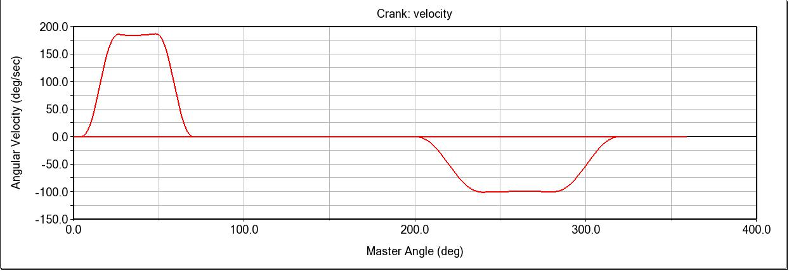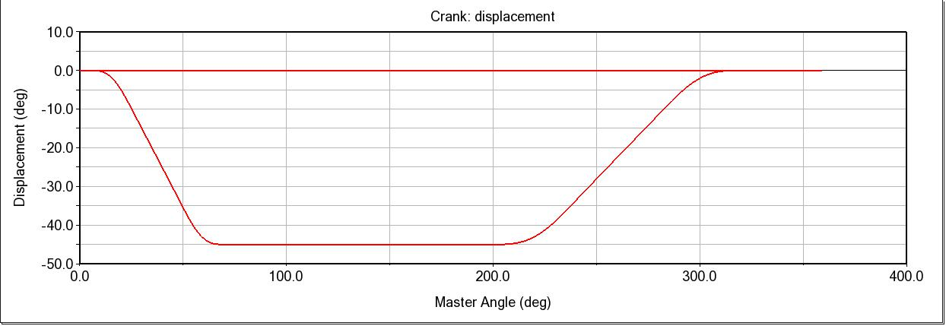The plots of displacement, velocity and acceleration of the crank are here shown:

The torque transmitted to the tilting pad:

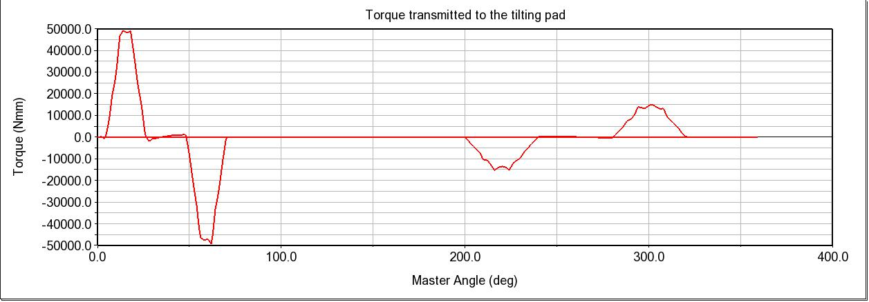

Regarding the cam, we can find the torque applied by the cam, that can be used to size the motor needed to move our mechanism:

The Pressure Angle of the cam:

As for the forces transmitted, the cam transmits to the follower these forces:

If we want to check these results, from the theory we know that the ratio between these forces is equal to the tangent of the pressure angle of the cam. In our case, this condition is verified.

We now want to know how the forces are transmitted, and in the end what percentage of the force transmitted by the cam is perceived by the crank.

Let’s begin with the forces transmitted by the follower to the coupler link:

Finally, the force that arrives at the crank:

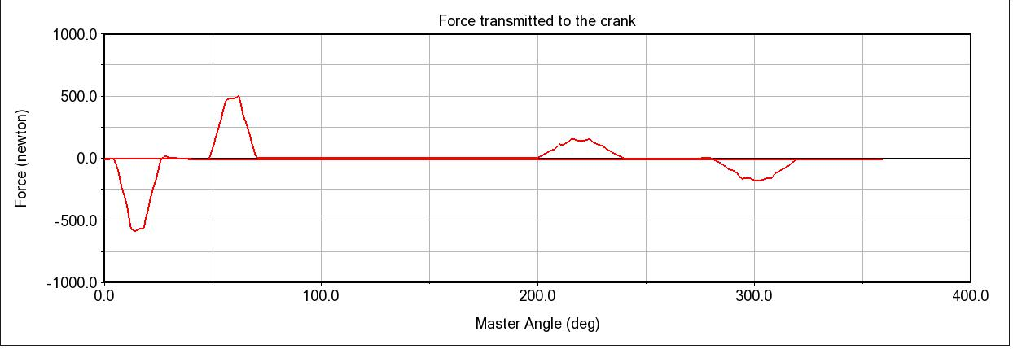

The maximum value of the force that arrives to the crank is 503 N, whereas the initial maximum value of the force transmitted by the cam is 667,5 N, calculated as the square root of the two components Fx and Fy represented in the plot shown before.